CD Lab #5
Question 1

// Write a recursive descent parser for the following simple grammars.

/*
Grammar:
S -> a | > | (T)
T -> T,S|S

We need to eliminate left recursion in the production of T
T -> ST'
T' -> ,ST' | ε

Therefore, the grammar is:
S -> a | > | (T)
T -> ST'
T' -> ,ST' | ε
*/

#include <stdio.h>
#include <stdlib.h>
#include <string.h>

int curr = 0;
char str[512];
void S();
void T();
void T_();

void invalid()
{
printf("Invalid String\n");
exit(-1);
}

void valid()
{
printf("Valid String\n");
exit(0);
}

void S()
{
if (str[curr] == 'a') {
curr++;return;
} else if (str[curr] == '>') {
curr++;
return;
} else if (str[curr] == '(') {
curr++;
T();

if (str[curr] == ')') {
curr++;
return;
} else {
invalid();
}
}
}

void T()
{
S();
T_();
}

void T_()
{
if (str[curr] == ',') {
curr++;
S();
T_();
}
return;
}

int main()
{
printf("Enter a string (Mark end of string with $):\n");
scanf("%s", str);
S();

if (str[curr] == '$') {
valid();
} else {
invalid();
}

return 0;
}

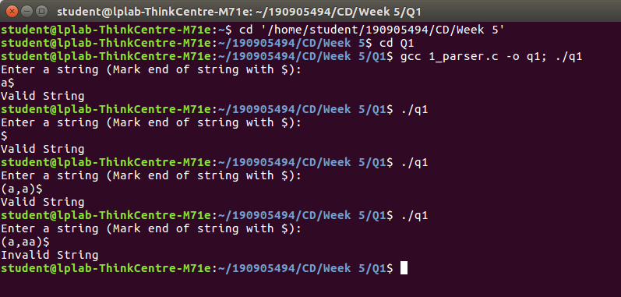

Question 2

// Write a recursive descent parser for the following simple grammars.

/* Grammar:
S -> UVW
U -> (S) | aSb | d
V -> aV | ε
W -> cW | ε

There is no left recurison in this grammar
*/

#include <stdio.h>
#include <stdlib.h>
#include <string.h>

int curr = 0;
char str[512];

void S();
void U();
void V();
void W();

void invalid() {
printf("Invalid String\n");
exit(-1);
}

void valid()
{
printf("Valid String\n");
exit(0);
}

void S()
{
U();
V();
W();
}

void U()
{
if (str[curr] == '(')
{
curr++;
S();
if (str[curr] == ')') {
curr++;
return;
}
else {
invalid();
}
}
else if (str[curr] == 'a') {
curr++;
S();
if (str[curr] == 'b') {
curr++;
return;
}
else {
invalid();
}
}
else if (str[curr] == 'd') {
curr++;
return;
}
}

void V()
{ if (str[curr] == 'a') {
curr++;
V();
}
return;
}

void W()
{
if (str[curr] == 'c') {
curr++;
W();
}
return;
}

int main()
{
printf("Enter a string (Mark end of string with $):\n");
scanf("%s", str);
S();
if (str[curr] == '$') {
valid();
}
else {
invalid();
}
return 0;
}

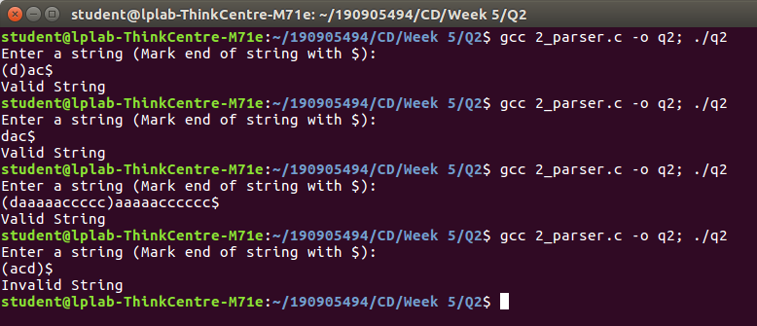
Question 3

// Write a recursive descent parser for the following simple grammars.

/*
Grammmar:
S -> aAcBe
A -> Ab|b
B -> d

The production rule for A has left recursion which needs to be eliminated
A -> bA'
A' -> bA' | ε

Therefore, the rules are:
S -> aAcBe
A -> bA'
A' -> bA' | ε
B -> d
*/

#include <stdio.h>
#include <stdlib.h>
#include <string.h>

int curr = 0;
char str[512];

void S();
void A();
void A_();
void B();

void invalid()
{
printf("Invalid String\n");
exit(-1);
}

void valid()
{
printf("Valid String\n");
exit(0);
}

void S()
{
if (str[curr] == 'a') {
curr++;
A();
if (str[curr] == 'c') {
curr++;
B(); if (str[curr] == 'e') {
curr++;
return;
}
else {
invalid();
}
}
else {
invalid();
}
}
else {
invalid();
}
}

void A()
{
if (str[curr] == 'b') {
curr++;
A_();
return;
}
else {
invalid();
}
}

void A_()
{
if (str[curr] == 'b') {
curr++;
A_();
}
return;
}

void B()
{
if (str[curr] == 'd') {
curr++;
return;
}
else {
invalid();
}
}

int main()
{
printf("Enter a string (Mark end of string with $):\n"); scanf("%s", str);
S();
if (str[curr] == '$') {
valid();
}
else {
invalid();
}
return 0;
}

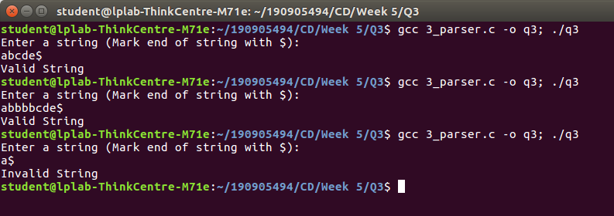

Question 4

// Write a recursive descent parser for the following simple grammars.

/*
Grammar:
S -> (L) | a
L -> L,S | S

The production rule for L is left recursive. This needs to be eliminated
L -> SL'
L' -> ,SL' | ε

Therefore, the grammar is:
S -> (L) | a
L -> SL'
L' -> ,SL' | ε
*/

#include <stdio.h>
#include <stdlib.h>
#include <string.h>

int curr = 0;
char str[512];

void S();
void L();
void L_();

void invalid()
{
printf("Invalid String\n");
exit(-1);
}

void valid()
{
printf("Valid String\n");
exit(0);
}

void S()
{
if (str[curr] == '(') {
curr++;
L();
if (str[curr] == ')') {
curr++;
return;
}
else {
invalid();
}
}
else if (str[curr] == 'a') {
curr++;
return;
}
else {
invalid();
}
}

void L()
{
S();
L_();
}

void L_()
{
if (str[curr] == ',') {
curr++;
S();
L_();
}
return;
}

int main()
{
printf("Enter a string (Mark end of string with $):\n");
scanf("%s", str);
S();
if (str[curr] == '$') {
valid();
}
else {
invalid();
}
return 0;
}

